**Smart Eating - Food Guide**

**Increment 3**

Project group 10

Sindhu Reddy Golconda - 14

Ravi Kumar Kurva -- 23

Uday Kiran Chowdary Mallineni - -28

Advaith Nandelli- - 34

CS5551 - Advanced Software Engineering

University of Missouri - Kansas City

October 14, 2016

**I. Introduction**

The project decided by Team 10 is to develop an application which can be used as a Food Guide as well as for smart eating. A person may have various diseases like sugar, high/low blood pressure and also he might have allergic reaction towards few food items like peanuts, milk. Hence he has to be very careful while consuming the food. Also when a person visits a new place and unable to find the appropriate restaurant then this application helps the user by providing the restaurants based on his choice.

**II. Objectives**

The main goal of the project is to develop a smart eating system which initially allows the user to find a restaurant by selecting a location, range of miles within which the restaurant should be searched, type of the restaurant which can be selected from a dropdown menu containing the details like Mexican, Chinese, Italian, Indian. Then the user can select all the allergies he has towards food and also the diseases he has.

A list of restaurants is populated based on the search criteria. Menu of the selected restaurant is then displayed which contains the details of all the food items and also it will suggest the user whether the food item contains the ingredients that are allergic to user and also if the item is healthy or not based on his diseases.

**III. Project Plan**

Team Members:

* Advaith Nandelli
* Sindhu Golconda
* Ravi Kumar Kurva
* Uday Kiran Mallineni

ZenHub Board for Increment 1:

Using Github and Zenhub, Issues for first Iteration are Created. The Zenhub board consisting of all the issues is listed as shown below.

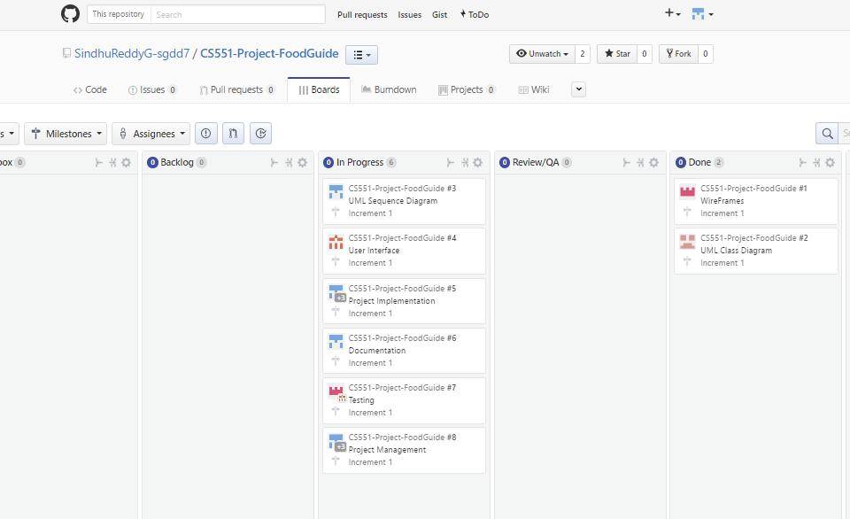

Zen Hub Board up to Increment 2 :

Using GitHub and Zen hub, Issues for Second Iteration are Created. The Zen hub board consisting of all the issues is listed as shown below.

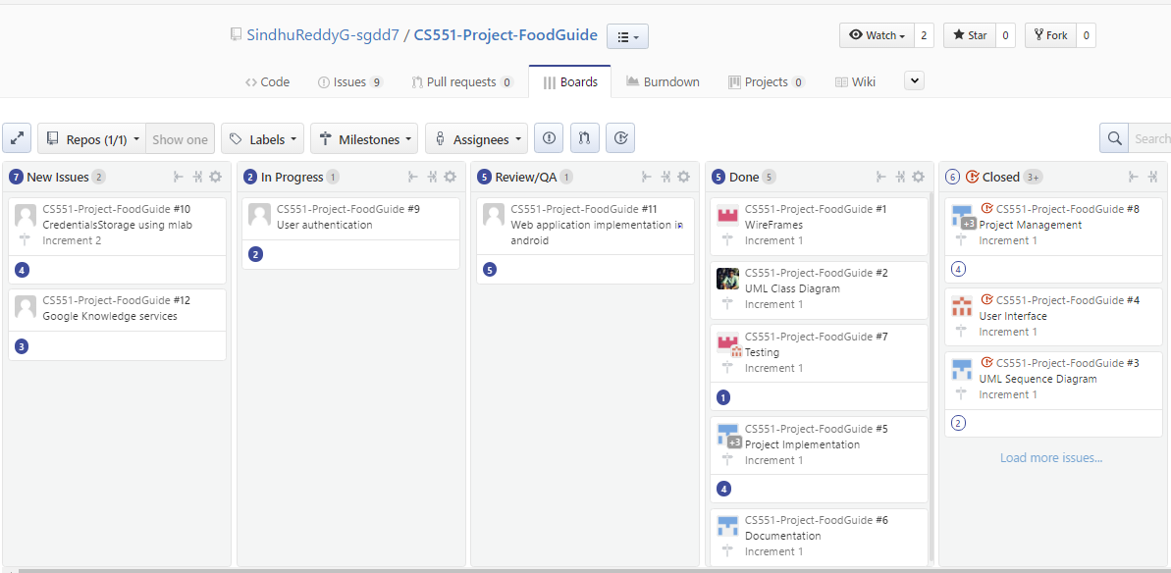

Zen Hub Board up to Increment 3:

Using GitHub and Zen hub, Issues for Third Iteration are Created. The Zen hub board consisting of all the issues is listed as shown below.

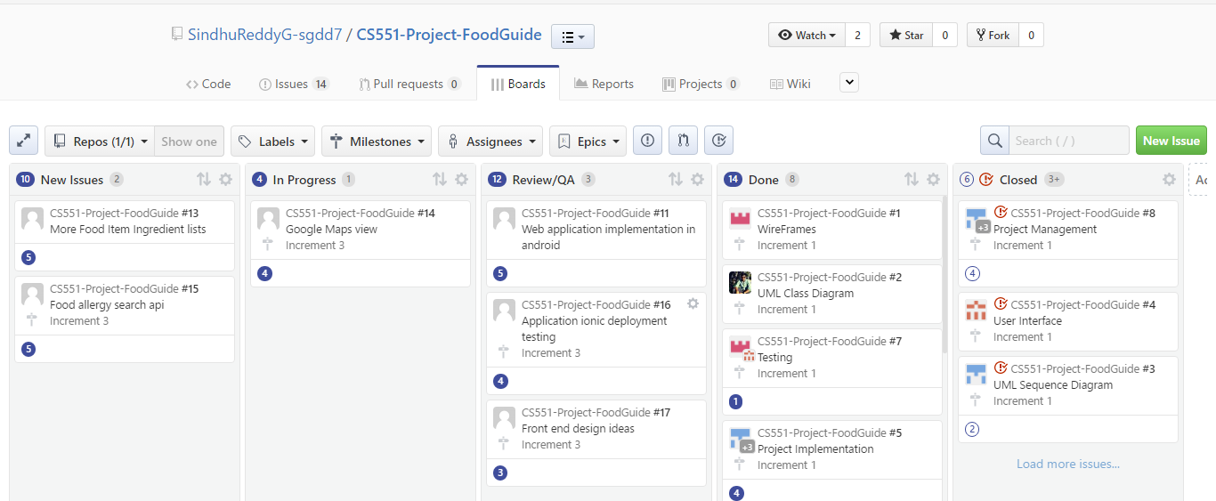

Burndown Chart for Increment 1

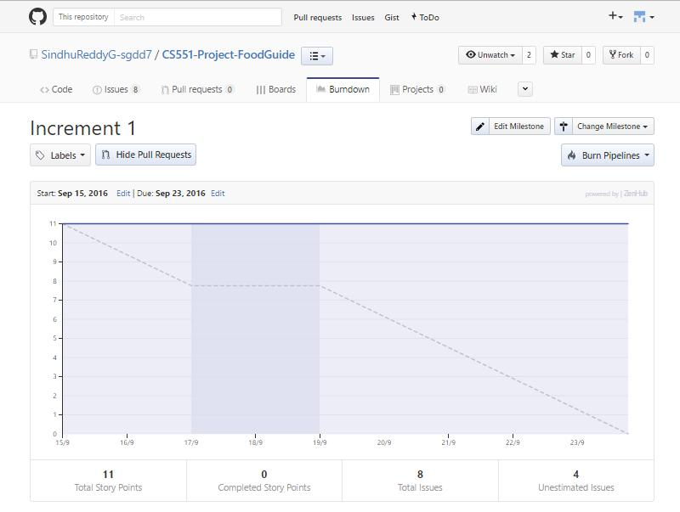

Burndown Chart for Increment 2:

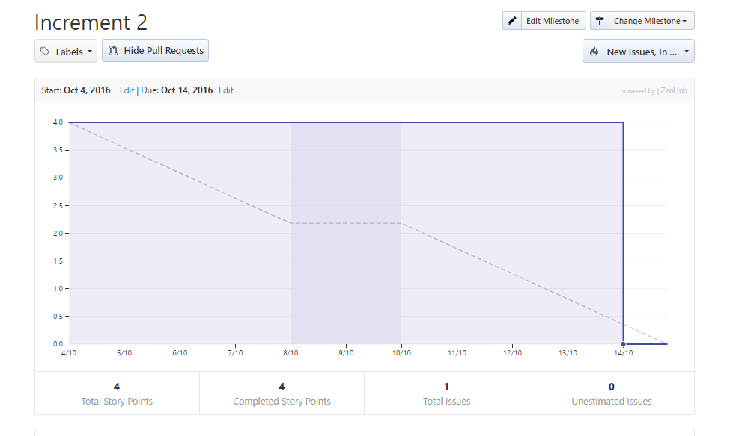

Burndown Chart for Increment 3:

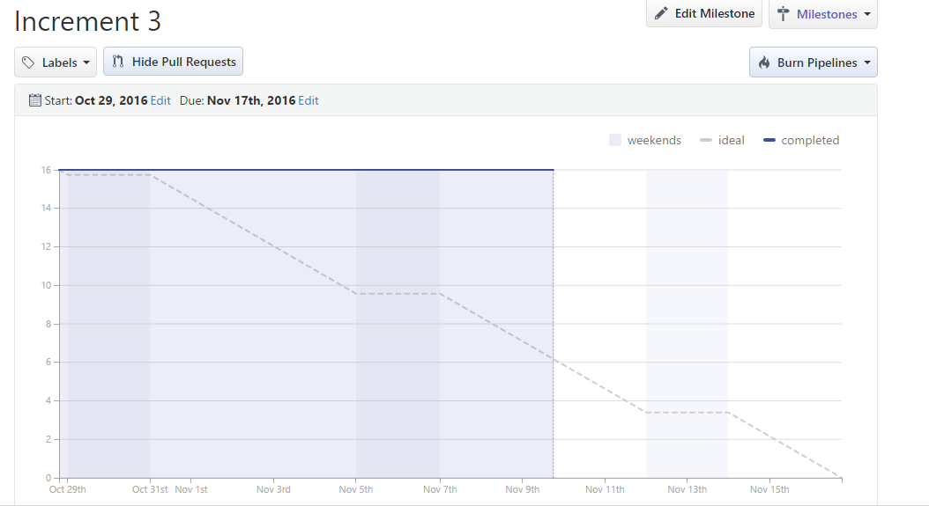

Existing Services/Rest API:

1. Foursquare API:
   * Used for retrieving Restaurants based on location and search query.
   * Also used for getting categories and menu items for a specific restaurant.

URL:  [https://api.foursquare.com/v2/venues](https://api.foursquare.com/v2/venues/)/

1. Google Knowledge graph search API:
   * Auto population of data in the textfield is implemented using this API. URL:  [https://developers.google.com/knowledge-graph](https://developers.google.com/knowledge-graph/)/
2. Edamam API:
   * This API is used to get ingredients for the different food items.

URL: <https://developer.edamam.com/>

1. The Yummly Recipe API :
   * It is used to get all the recipe’s and ingredients of the food items.

URL: <https://developer.yummly.com>

1. Mlab online database service
   * By using this service, we are implementing the online user account database to login

URL: <https://mlab.com/databases/SmartEating>

1. Google Maps API

* We are using the google maps API to display the restaurant location in google maps.

URL: <https://developers.google.com/maps/>

**Detail Design of Features:**

Wireframes:

Login page:

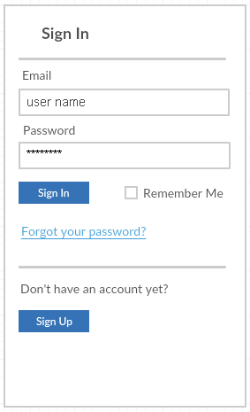

Register page:

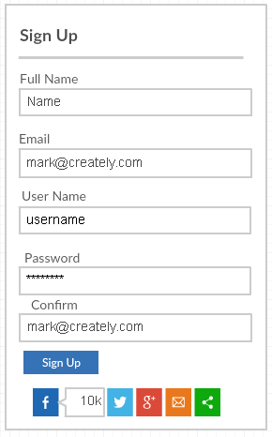

Mobile app. main search page:

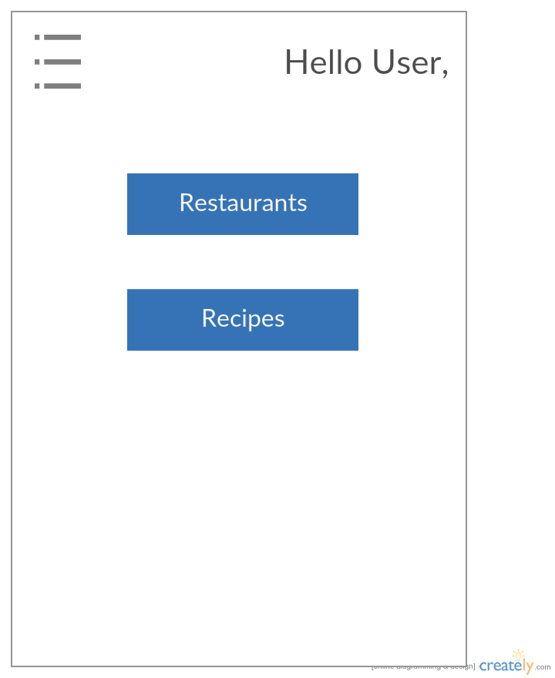

Restaurant Result page: in this page we will display best resulted restaurants based on the given input options by the user.

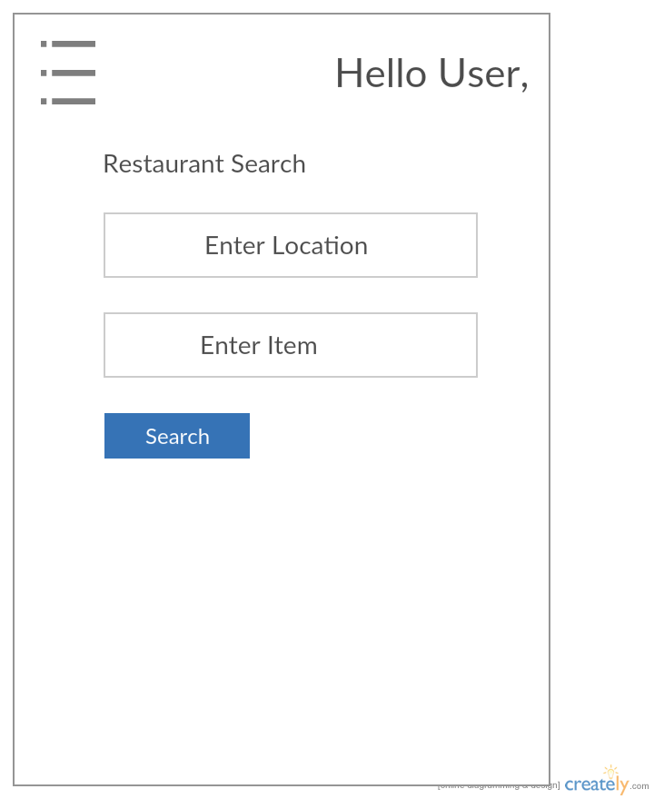

Search Result :

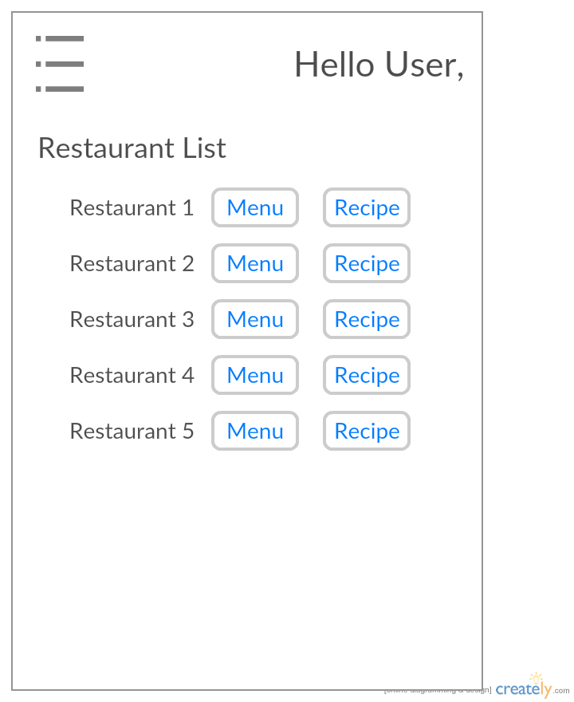

Menu page:

In this page we will display the menu with the items and health concern to give the user feedback whether is it good or bad to his health by indicating green / red mark.

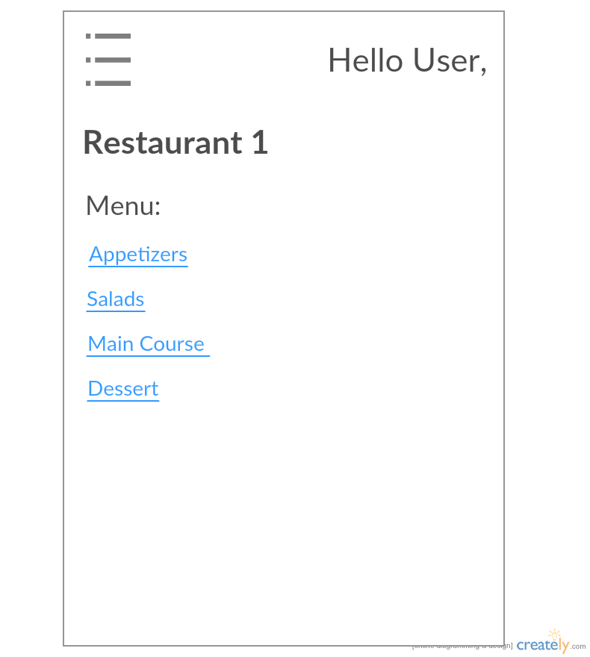

Allergic food page: In this page user can specify the which items he his allergic so that we can give him food options without them like some members will allergic to the peanut we can give him food items list which don’t have the peanuts in it.

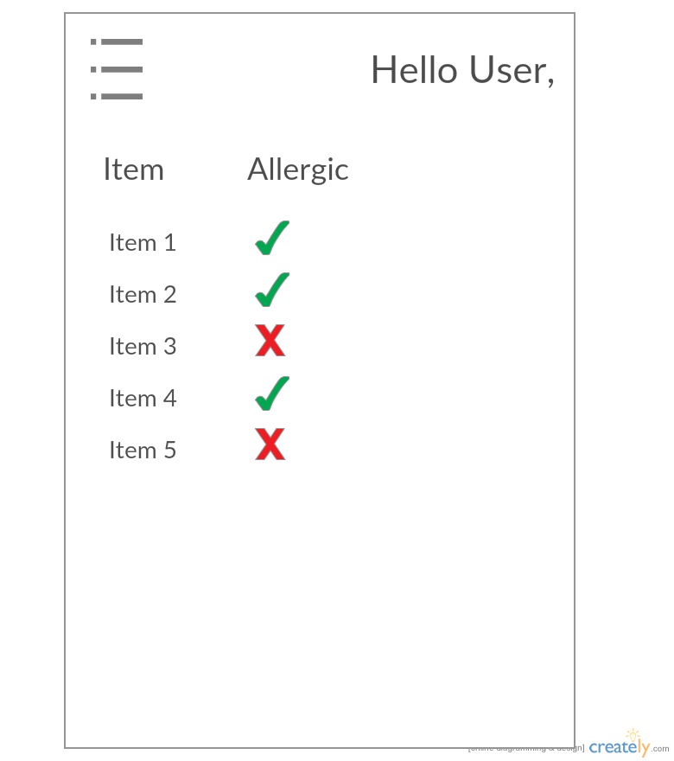

Recipe Search :

User can search the Ingredients of the Food item, So that he can prepare that food at home. Here we have used the edamam API to search the food ingredients.

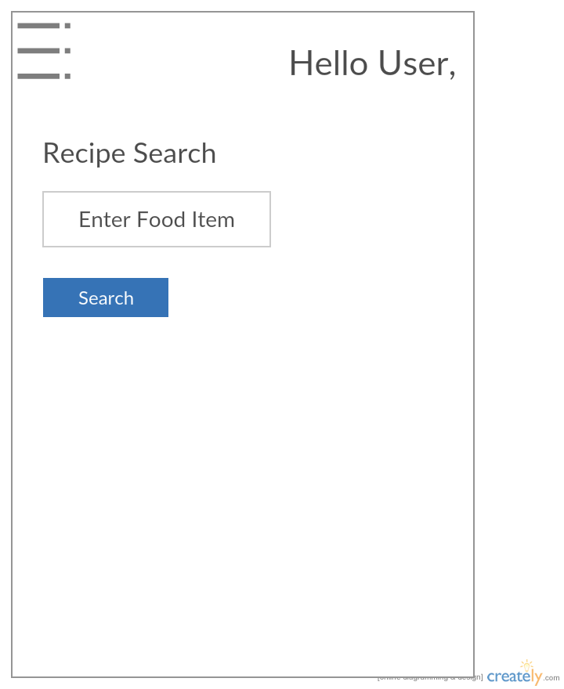

Recipe Result page :

Here user will get the relavent search results items list based on the food item

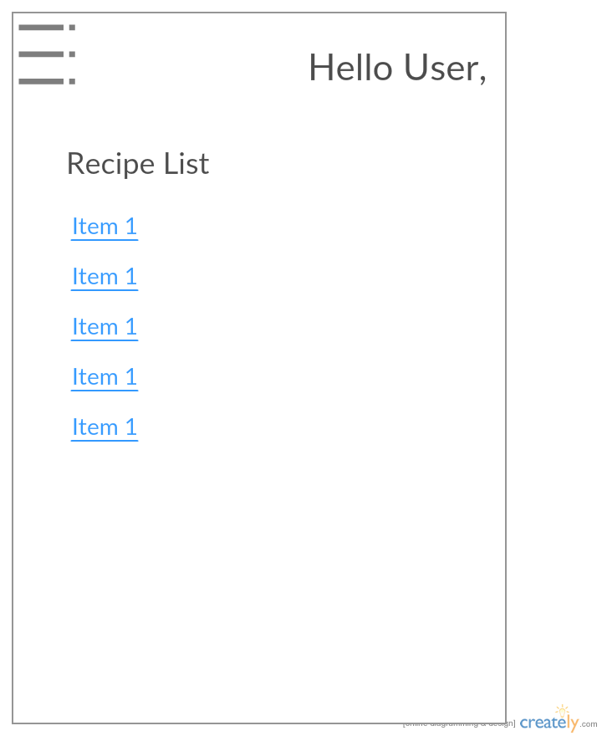

Ingredient result :

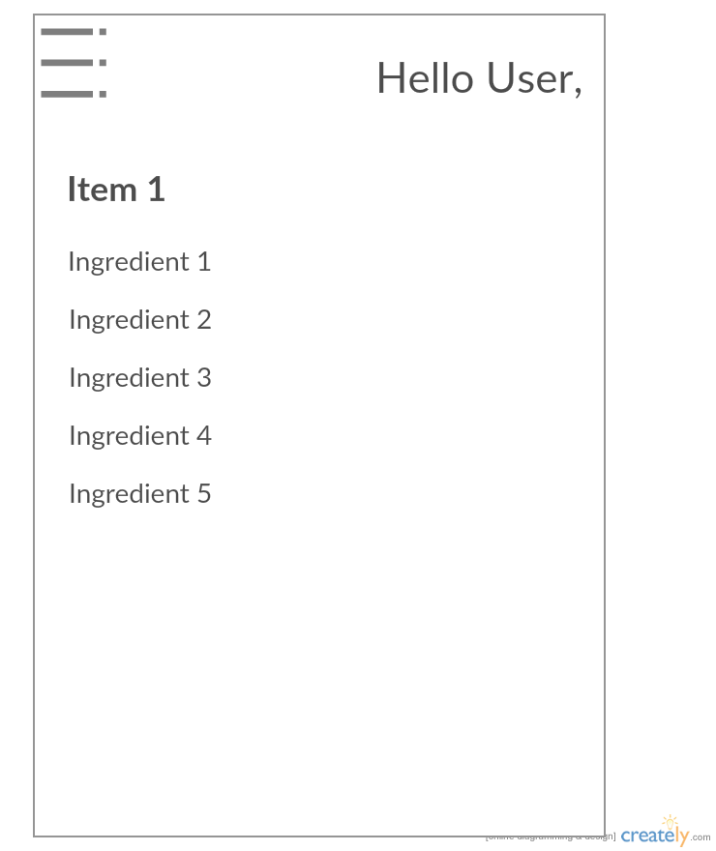

Architecture Diagram:

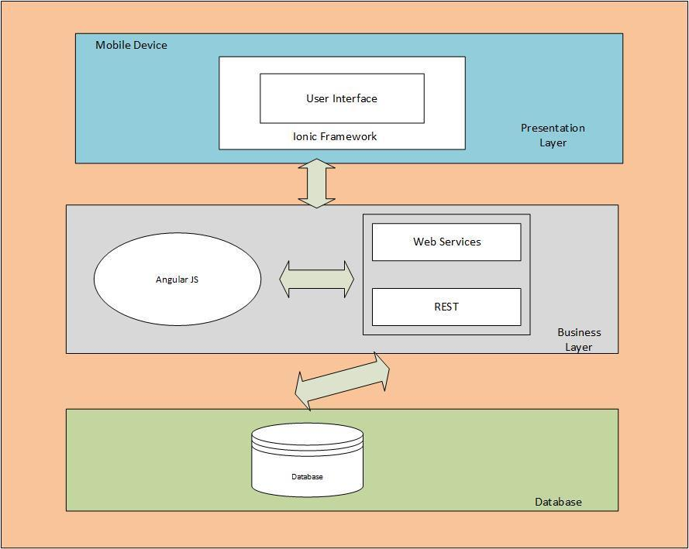

UML Class Diagram:

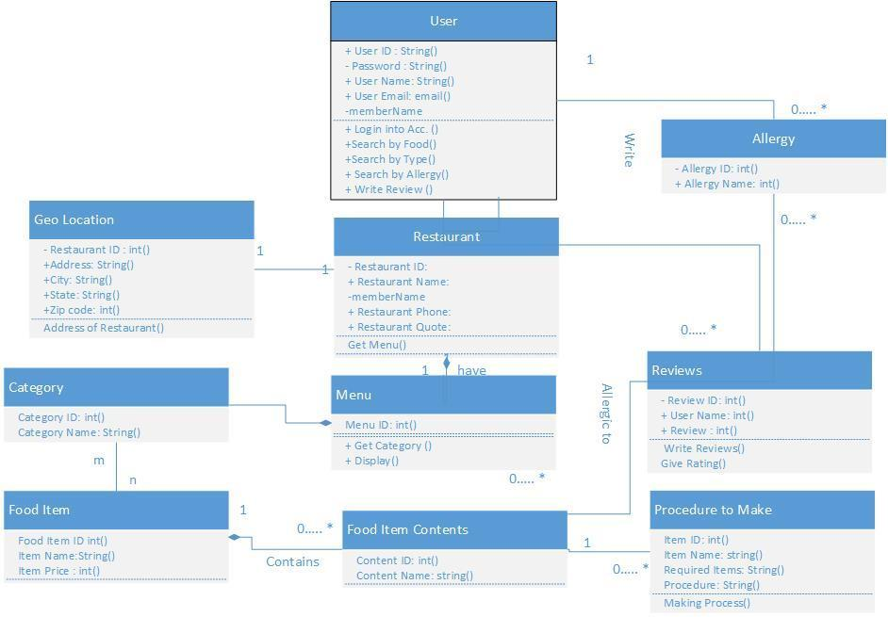

UML Sequence Diagram:

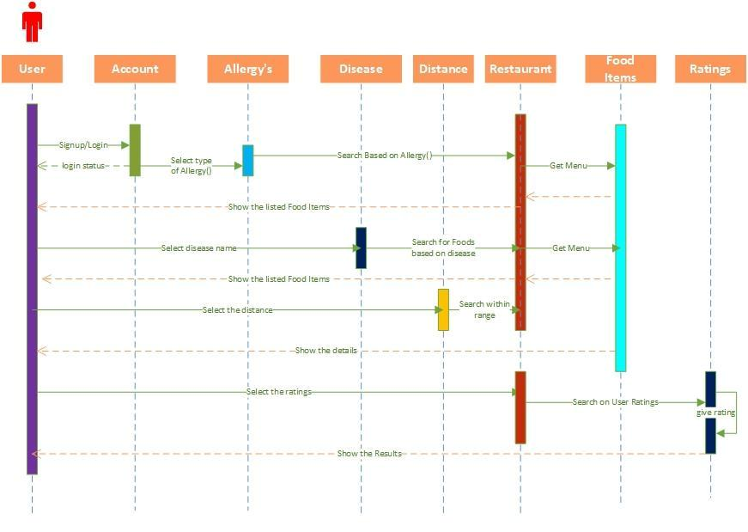

**Project Deployment:**

User Registration:

In this page user is able to enter his/ her credentials into the our application in order to signup and all the details will be stored in the online mlab database ( mongo dB).

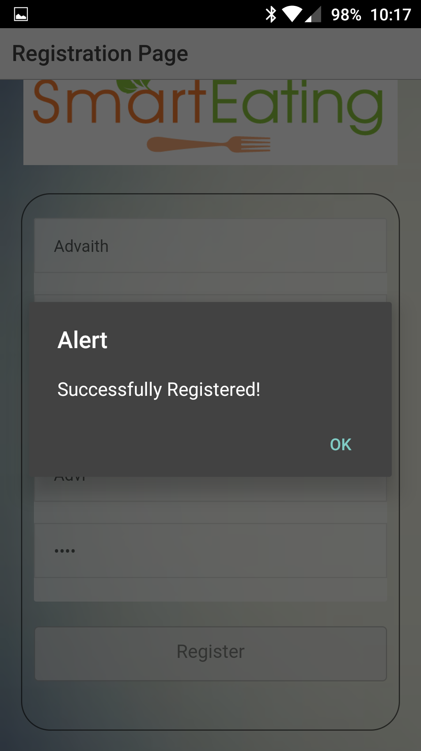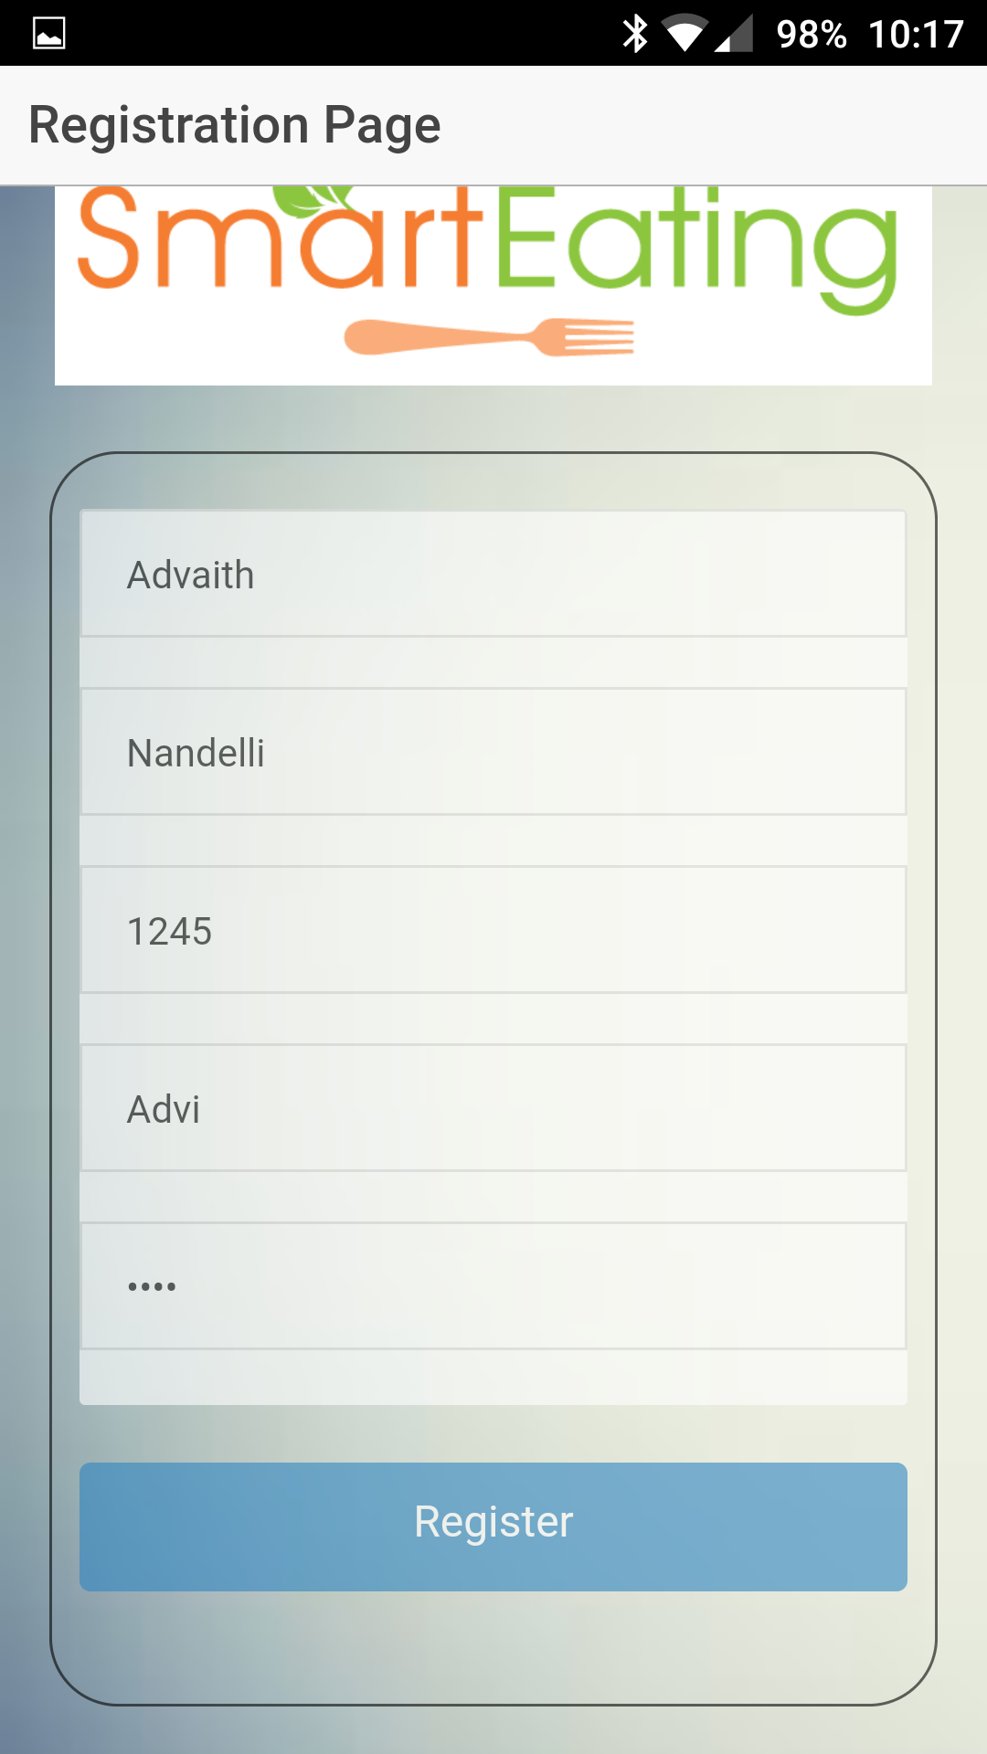

User Login :

In this page user is able to login into his account with the valid credentials.

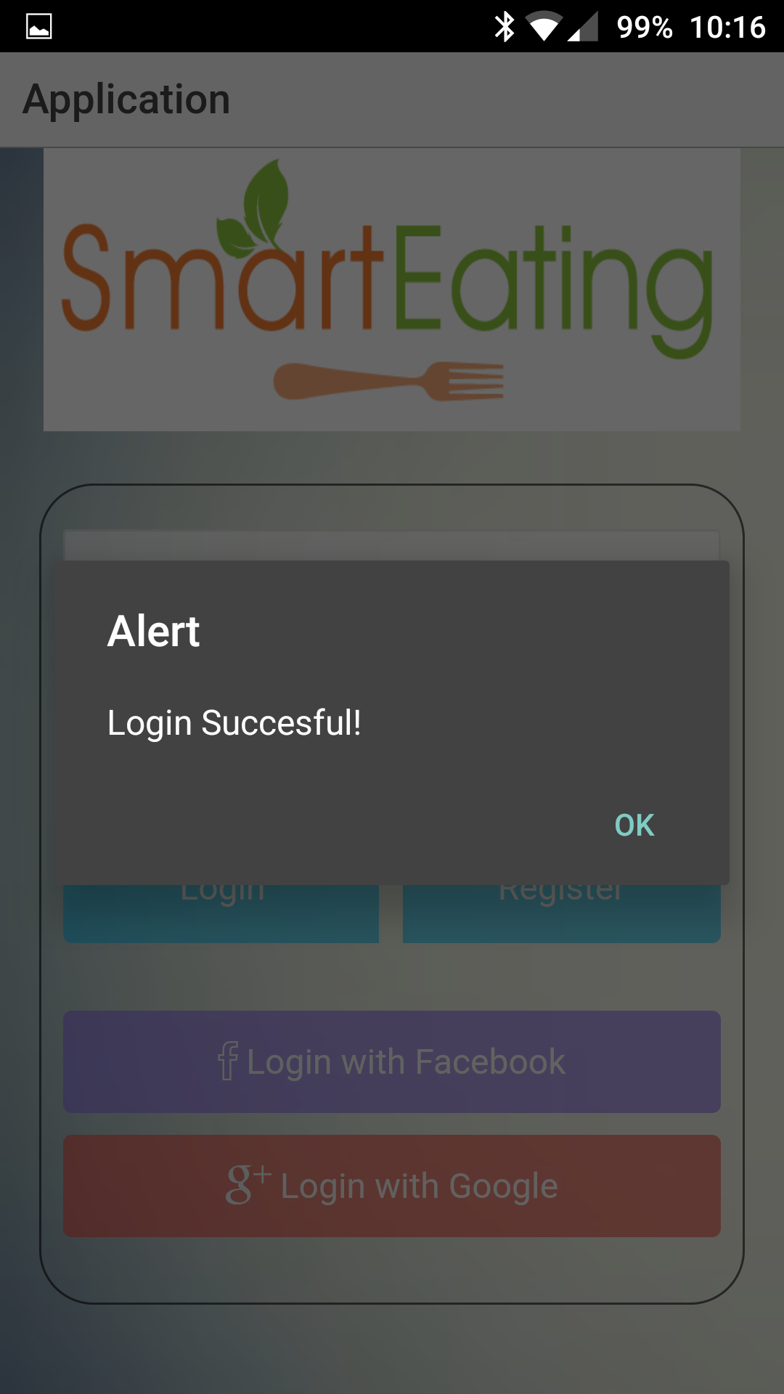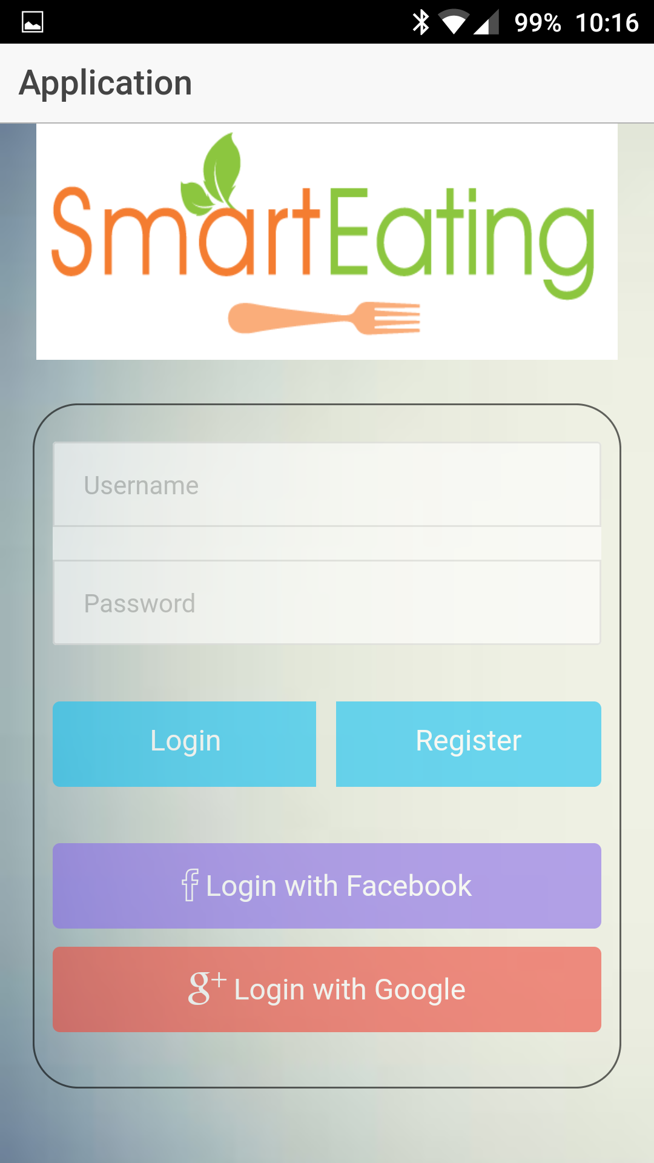

We will validate the user credentials, if they match the online database username and password it will give the user a successful login pop message and then redirected to the home page.

Home page :

In this page where user select search recipe or search restaurant to try new food.

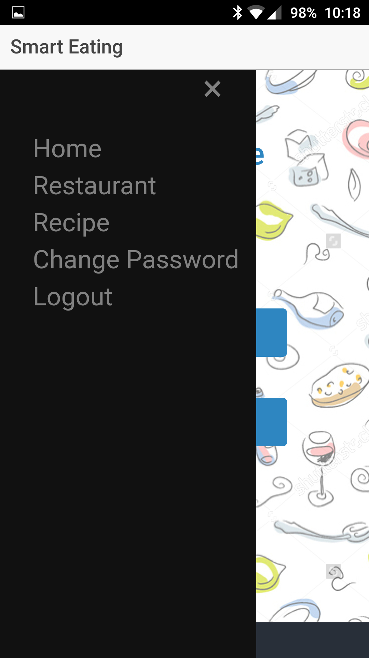

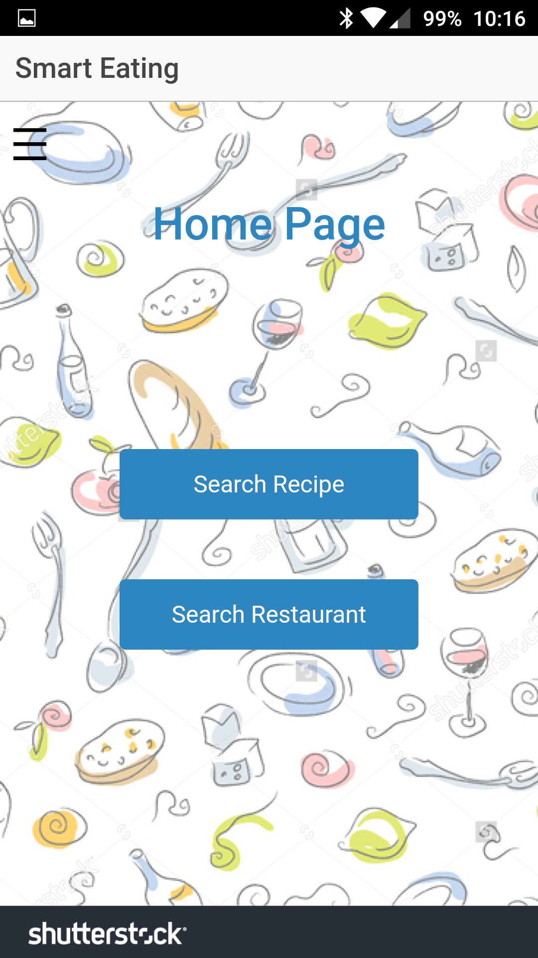

Search Recipe: Here in this page user can search the food items to get their recipe’s

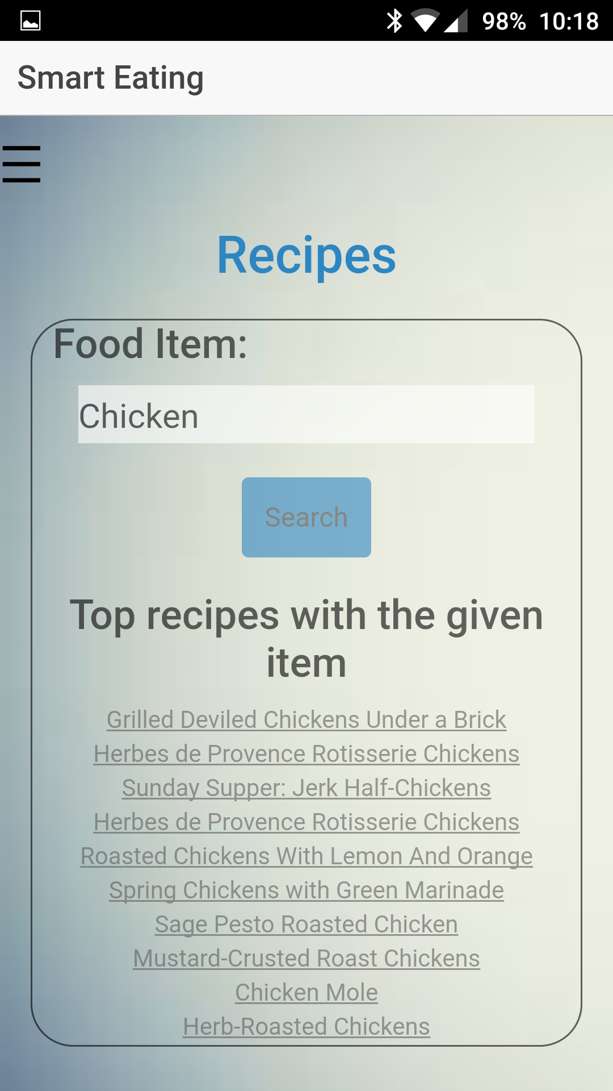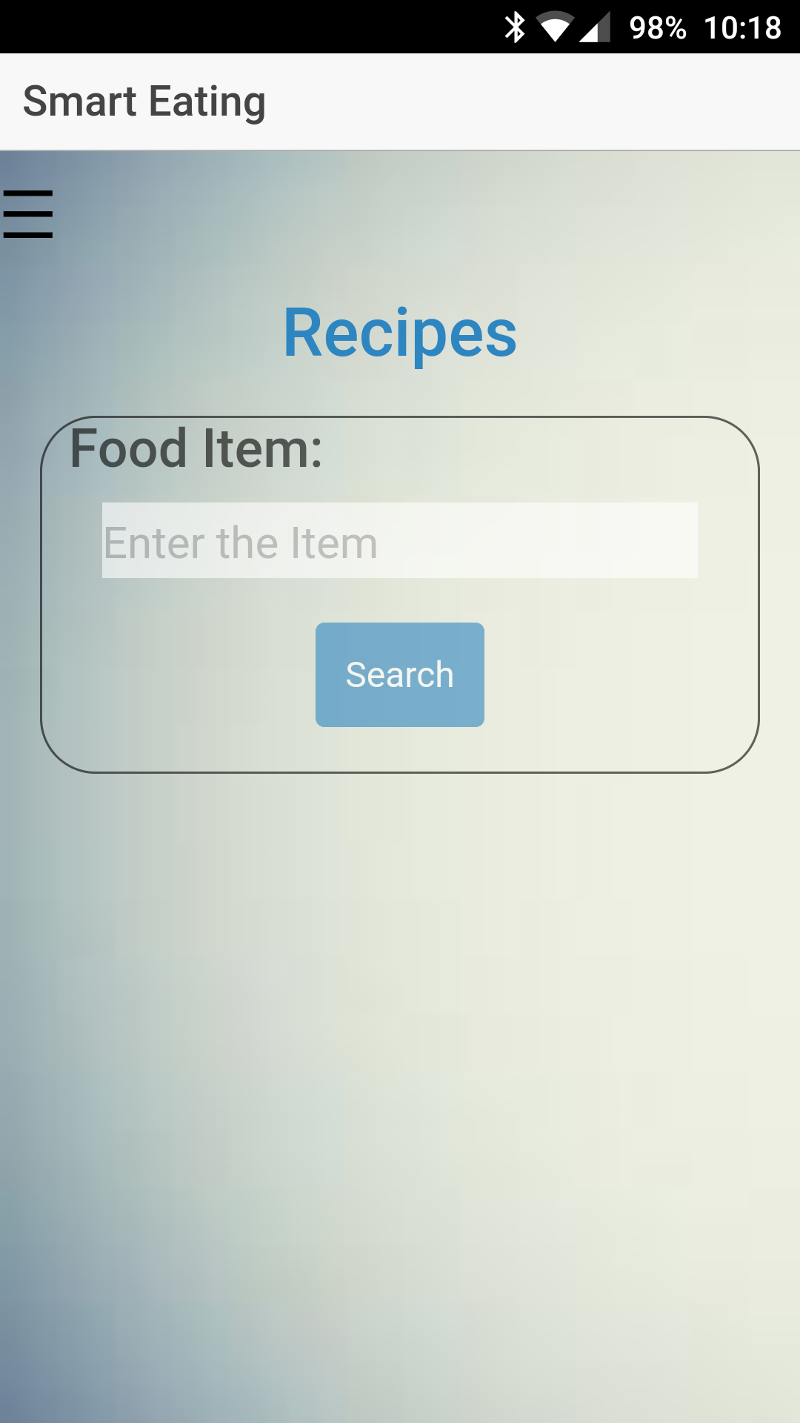

User can also get the images of the food items as well as the ingredients as shown below

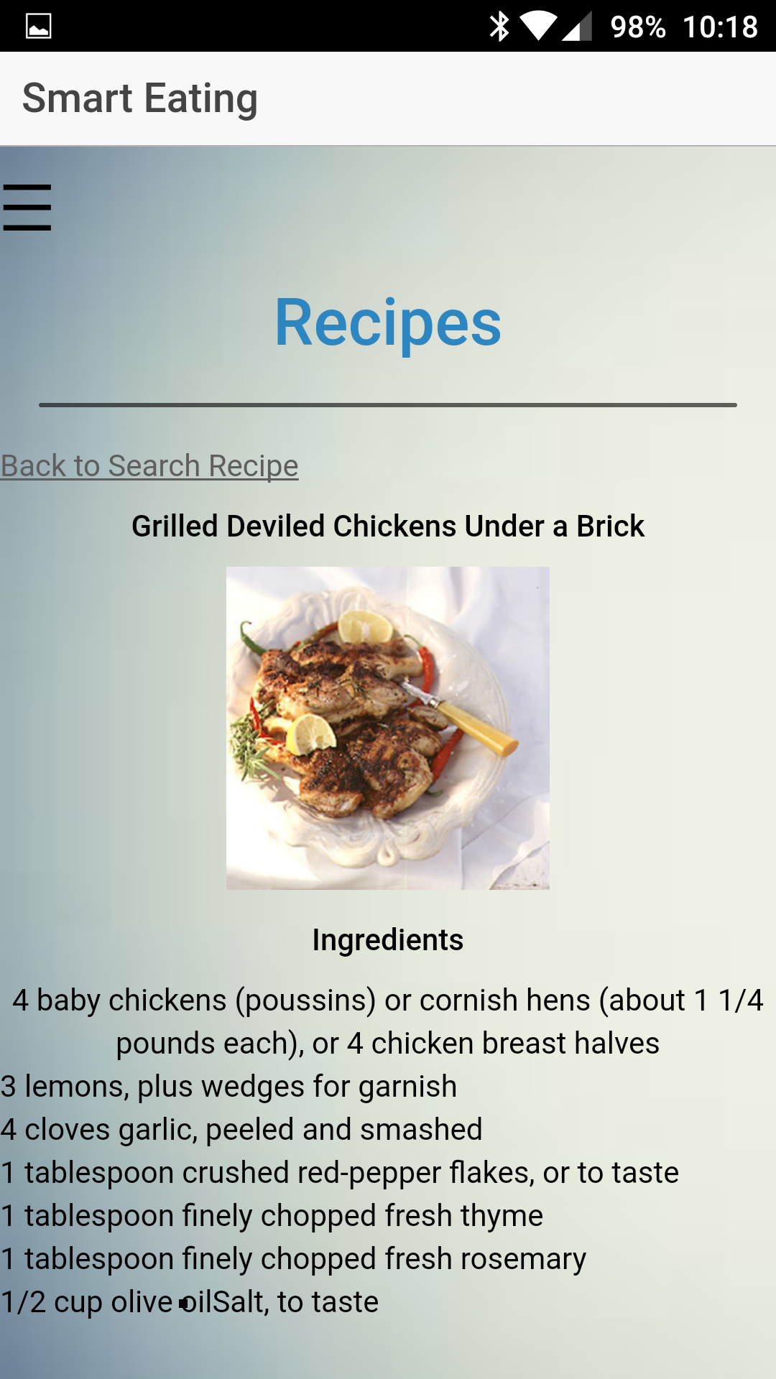

Restaurant Search :

Once he selects the place and which type of the food he wants to try we will display all the results related to the search field.

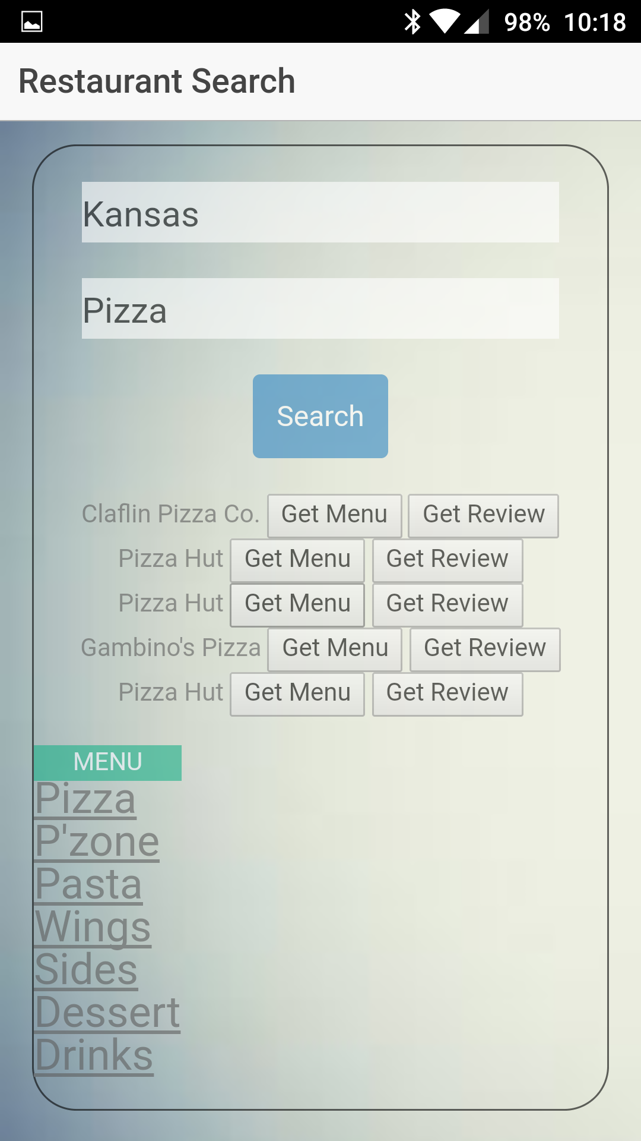

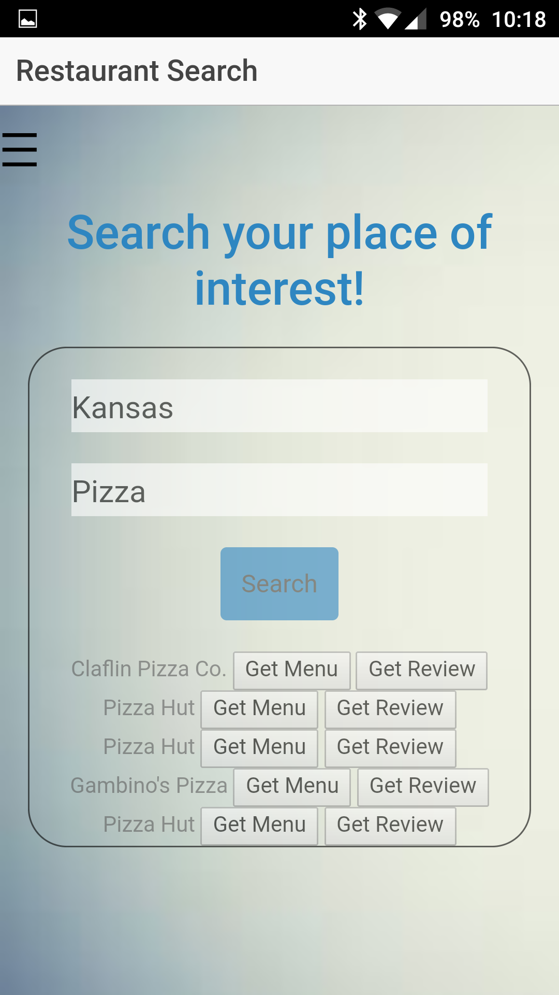

After getting the results we will display the restaurant name and menu and reviews from the previous users. Menu button will show the restaurant menu with the item names.

User Reviews: Here we will display the review of the food item from the previous customer.

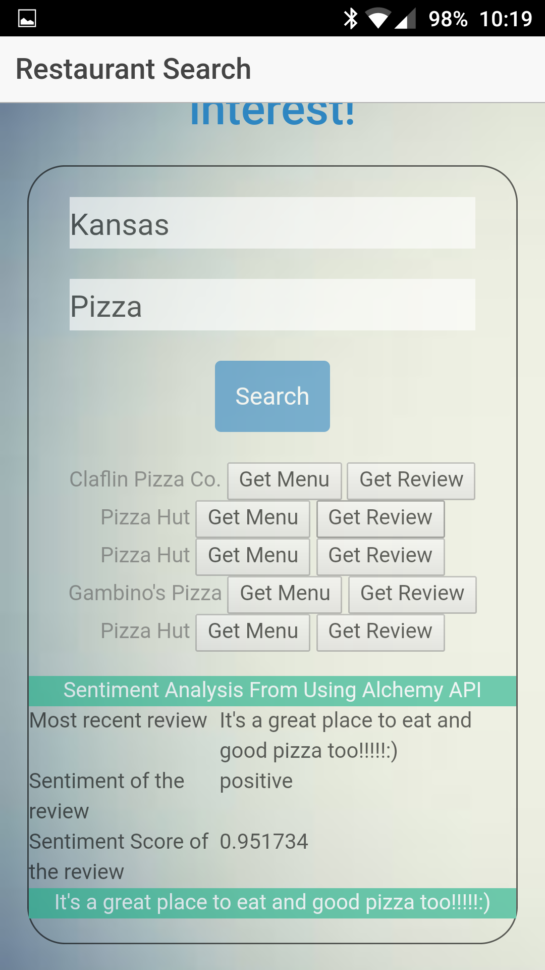

Deployment in browser:

we have deployed our application in web browser and android platform the web browser screen shoots are posted below android screen shots are posted already in above pages.

webapplication login :

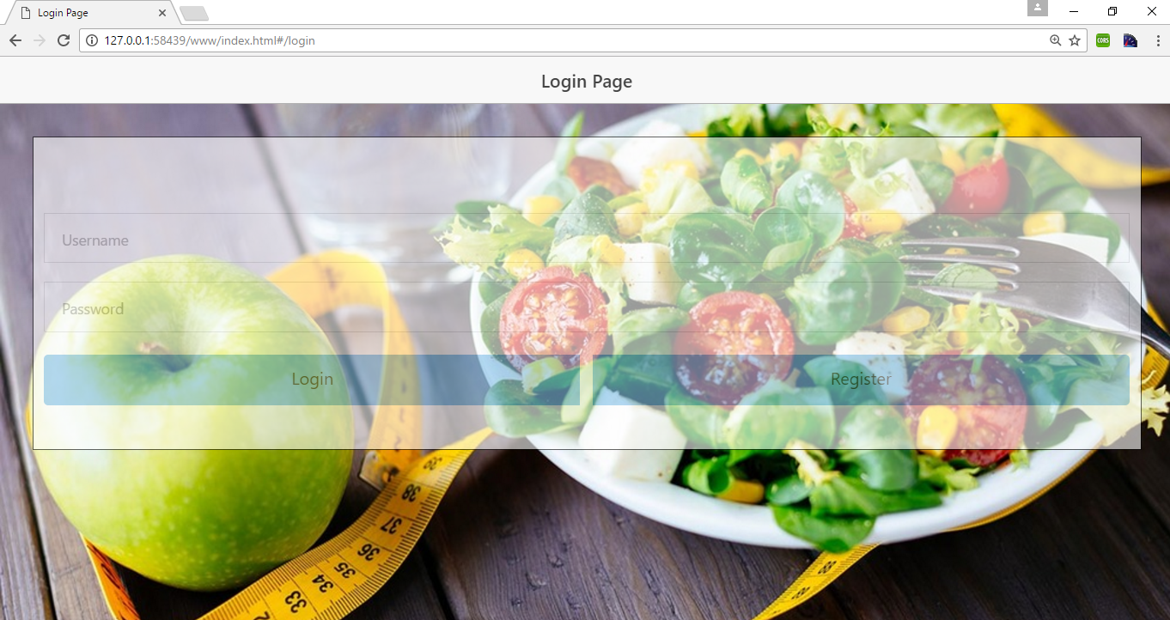

Register page :

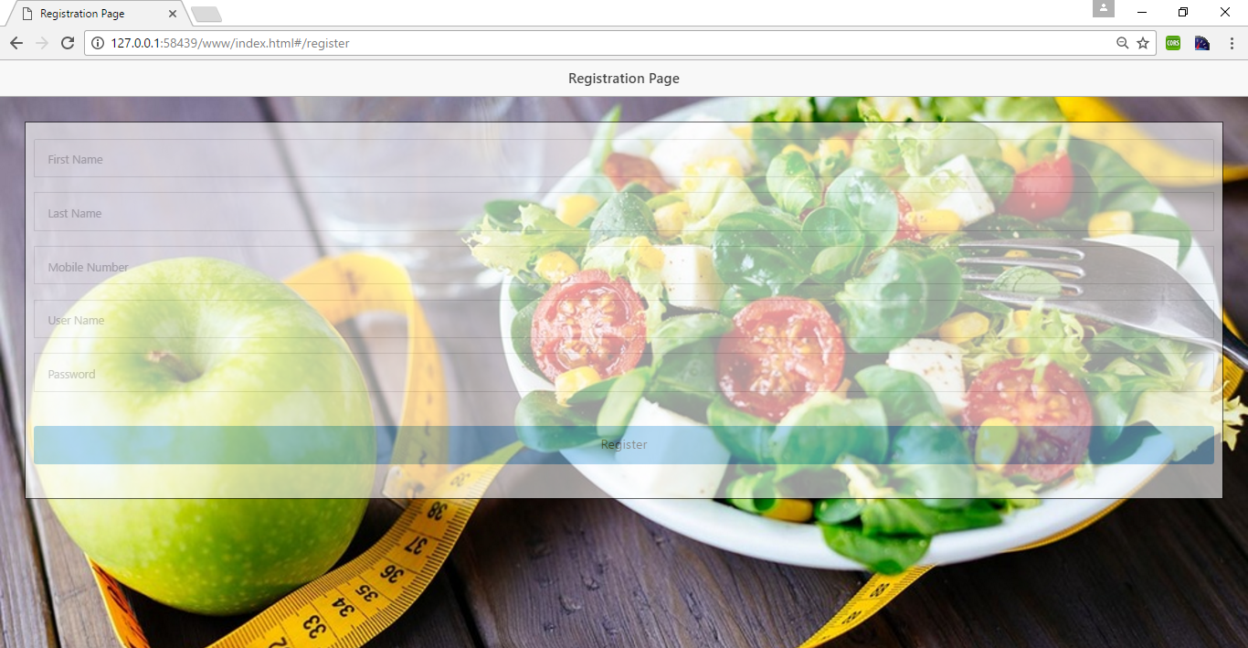

Home page:

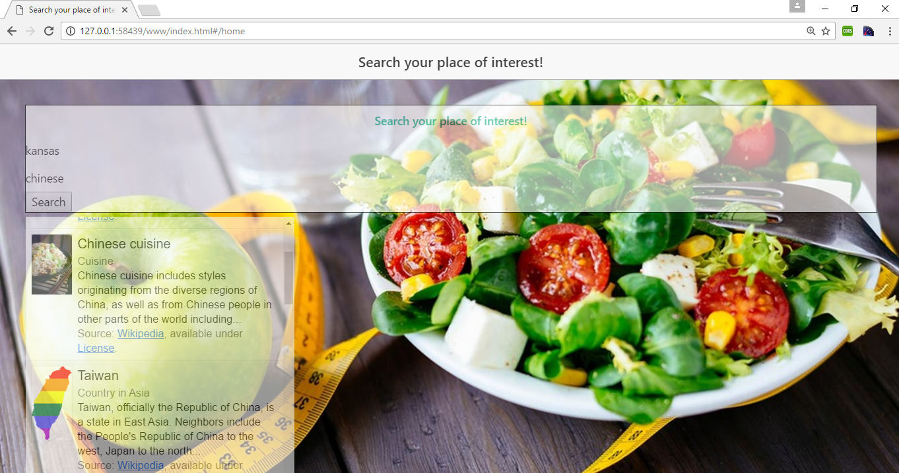

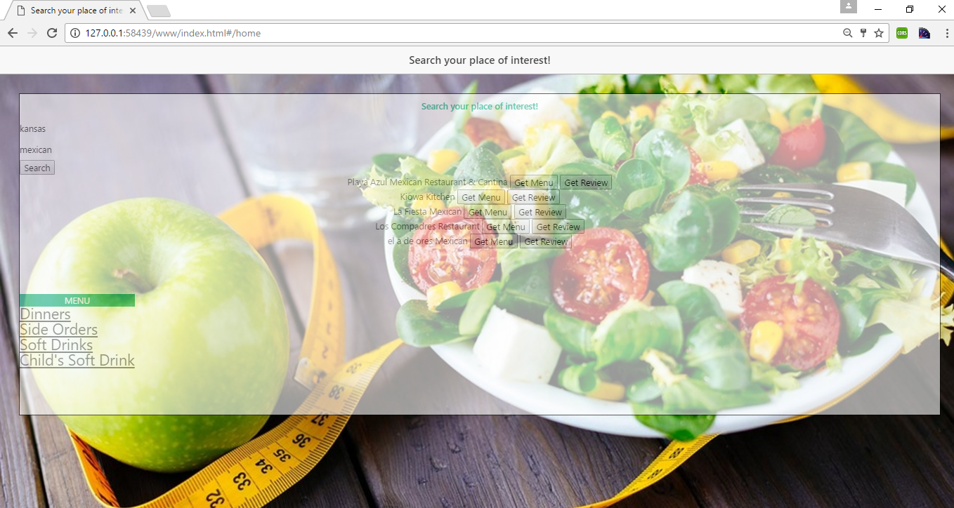

**Server Implementation:**

Database for User account data:

In our project we are using the mlab online mongo dB data base, in this database we are storing the all the user information.

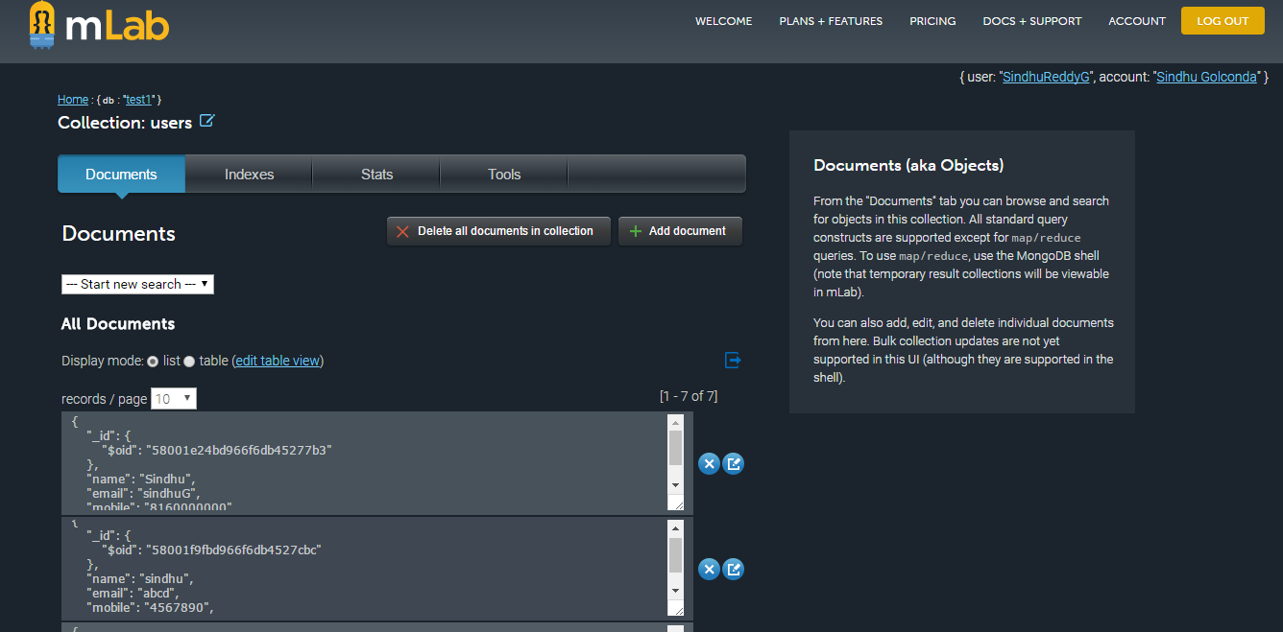

**GITHUB URL:**

Source code GITHUB link is provide below:

Github URL:  [https://github.com/SindhuReddyG-sgdd7/CS551-Project-FoodGuid](https://github.com/SindhuReddyG-sgdd7/CS551-Project-FoodGuide)e

**Project Management:**

* **User account database development :** User account details are stored in the mlab’s online mongo database.
  + Contributors: Advaith, Ravi
* **User credentials validation test cases :** User login credentials are validated with the values in database of mongo lab.
  + Contributors: Sindhu, Uday
* **Web application User Interface: F**ront end idea and implementation of webpages in html.
  + Contributors: Uday, Advaith
* **Android application Development: F**ront end idea and implementation of android application design idea in mobile.
  + Contributors: Sindhu, Ravi
* **Application Program Interface Use Cases:**  Implementation of different use cases from the Web API like ingredient search, items and allergy’s.
  + Contributors: Sindhu, Ravi, Advaith, Uday
* **Restaurant Name Search:** Using Foursquare API, the restaurants are retrieved

based on location and search query.

* + Contributors: Advaith, Ravi, Sindhu, Uday
* **Menu and Item Search:** For the selected restaurant, Menu is retrievedwhich contains different Categories of items using foursquare API. By selecting the Category, all the items belonging to particular category are displayed.
  + Contributors: Uday, Sindhu
* **Android Application deploying and debugging** : We had deployed our application in android platform using Ionic.
  + Contributors: Sindhu, Ravi.
* **Web Application deploying and debugging:** We had deployed our
* **Application testing:** Deployed application is then tested using JLint and YSlow for better performance.
  + Contributors: Advaith, Uday
* **Restaurant Review:** Reviews of selected restaurants are retrieved using IBMWatson API.
  + Contributors: Uday, Sindhu

**Bibliography:**

<https://developers.google.com/knowledge-graph/how-tos/search-widge>t  [https://developer.foursquare.com/overview/realtim](https://developer.foursquare.com/overview/realtime)e  [https://webdesign.tutsplus.com/articles/making-websites-location-aware-with-html5-geolocation](https://webdesign.tutsplus.com/articles/making-websites-location-aware-with-html5-geolocation--webdesign-10495)- [-webdesign-1049](https://webdesign.tutsplus.com/articles/making-websites-location-aware-with-html5-geolocation--webdesign-10495)5

[http://www.w3schools.com/html/html5_geolocation.as](http://www.w3schools.com/html/html5_geolocation.asp)p  [http://www.w3schools.com/js/default.as](http://www.w3schools.com/js/default.asp)p  [https://www.jetbrains.com/webstorm/features/coding-assistance.htm](https://www.jetbrains.com/webstorm/features/coding-assistance.html)l  [https://developer.android.com/studio/intro/index.htm](https://developer.android.com/studio/intro/index.html)l  [http://mycaption.com/resources/technology/voice-recognitio](http://mycaption.com/resources/technology/voice-recognition)n

<https://colorlib.com/wp/html5-and-css3-login-forms/>

<https://cordova.apache.org/>